**COMET BAY COLLEGE**

**Physics Unit 4 – Task 8**

**Light Waves Validation Test**

**Name: SOLUTION Total Marks /40**

**Part A** has to be handed in at the **commencement** of this test.

Standard school penalties apply for not meeting the deadline.

|  |  |
| --- | --- |
| Part A | /10 |
| Part B | /40 |
| Total | /50 | % |

1. Reflecting back on the experiment you completed what did the trend of your experiment suggest about the relationship between the density of the medium and the velocity at which light travels through it. (1 mark)

**As the density increased, then the velocity of light decreased (1 mark)**

___________________________________________________________________

1. Assuming that the slit of light was perfectly aligned with the medium, that is the entry point had a tangent perpendicular to the normal, discuss two errors and in detail, how they would affect the results. (4 marks)

**Reasonable error (1 mark)**

**Detailed explanation, include expected changes to values or trend (1 mark)**

_____________________________________________________________________________________________________________________________________________________________________________________________________________________________________________________________________________________________________________________________________________________________________________________________________________________________________________________________________________________

1. Using your knowledge of Snell’s Law and refraction explain how this type of experiment could be relevant to the real world and improve society. (4 marks)

**Reasonable field of study (1 mark)**

**Detailed on how it could be used (1 mark)**

**Detail on how this improves society (1 mark)**

__________________________________________________________________________________________________________________________________________________________________________________________________________________________________________________________________________________________________________________________________________________________________________________________________________________

A group of students in your class (Bob, Chris and Beccy) are also conducting an experiment similar to yours. However, instead of light passing through different mediums of different densities they are passing different coloured lights through the one medium – glass.

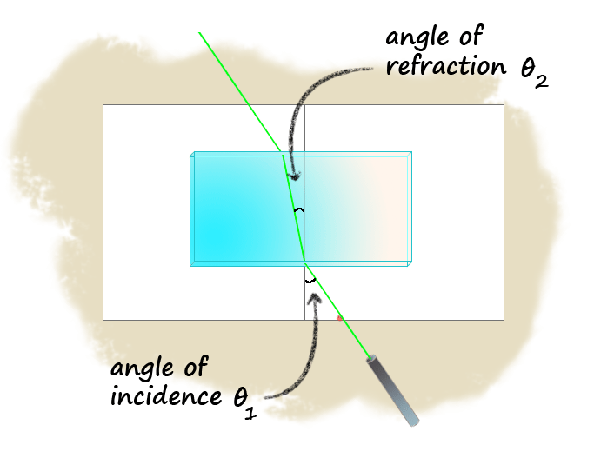

$\frac{sin θ_{i}}{sin θ_{r}}$**= $\frac{v_{i}}{v_{r}}$ = $\frac{λ_{i}}{λ_{r}}$ = $\frac{n_{r}}{n_{i}}$**

**Figure 1: Showing the green light passing through the glass medium**

1. Explain how wavelength and velocity are linked in relation to your understanding of electromagnetic radiation. (3 marks)

__________________________________________________________________________________________________________________________________________________________________________________________________________________________________________________________________________________________________________________________________________________________________________________________________________________

**v = λ × f (1 mark)**

**Frequency remains constant when passing through mediums (1 mark)**

**Hence velocity directly proportional to λ (1 mark)**

They have selected 5 LED laser lights, all of known frequencies.

Speed of electromagnetic radiation in air is calculated to be vair = 2.98964 x 108 m s-1.

The following results were recorded.

1. Complete the table of data. (working space below table ) (2 marks)

**Table 1: Laser lights and their known frequencies in air.**

**Table 1: Laser lights and their known frequencies in air.**

|  |  |  |
| --- | --- | --- |
| Laser light colour | Frequency in air (THz) | Wavelength in air  (nm) |
|
| Blue | 610 | 490 |
| Green | 560 | 534 |
| Yellow | 515 | 581 |
| Red | 460 | 650 |

**minus 1 mark for each incorrect**

|  |  |  |
| --- | --- | --- |
| Laser light colour | Frequency in air (THz) | Wavelength  (nm) |
|
| Blue | 610 |  |
| Green | 580 |  |
| Yellow | 515 |  |
| Red | 460 |  |

1. The students completed their experiment and the averages were recorded below.

(6 marks)

**Table 2: Wavelength and Percentage uncertainties of laser lights**

|  |  |  |  |  |  |  |
| --- | --- | --- | --- | --- | --- | --- |
| Light Colour | Practical **θi** | Practical **θr** |  | %uncertainty | Wavelength in air (nm) | Wavelength in glass (nm) |
| Blue | 59 | 34 | 1.53 | ± 2.58% | 490 | 320 |
| Green | 65 | 37 | 1.51 | ± 2.41% | 534 | 355 |
| Yellow | 42 | 27 | 1.47 | ± 3.23% | 581 | 394 |
| Red | 53 | 34 | 1.43 | ± 2.65% | 650 | 455 |

**minus 1 mark for each incorrect**

**no follow through as each column is/ should be independent of the others**

**Table 2: Wavelength and Percentage uncertainties of laser lights.**

|  |  |  |  |  |  |  |
| --- | --- | --- | --- | --- | --- | --- |
| Light Colour | Practical **θi** | Practical **θr** |  | %uncertainty | Wavelength in air (nm) | Wavelength in glass (nm) |
| Blue | 59 | 34 |  |  |  |  |
| Green | 65 | 37 |  |  |  |  |
| Yellow | 42 | 27 |  |  |  |  |
| Red | 53 | 34 |  |  |  |  |

1. Calculate $\frac{sin θ_{i}}{sin θ_{r}}$ and fill this in in the table above. Show working for the blue light in the space below. (1 mark)

$\frac{sin θ_{i}}{sin θ_{r}}$**= $\frac{sin 59}{sin 34}$ = 1.53 (1 mark)**

1. Assuming the students used a similar protractor to the one you used with one degree graduations, calculate the percentage uncertainty for $\frac{sin θ_{i}}{sin θ_{r}}$. Show working for the blue light in the space below. (2 marks)

**Use of a protractor which is at 1 degree intervals.**

**Calculation is a division, therefore must add percentage uncertainties.**

**Calc % unc for table 1**

$θi =\frac{(sin 0.5)}{(sin 59)} × 100$**= 1.02 %** (1 mark)

$θr =\frac{(sin 0.5)}{(sin 34)} × 100$**= 1.56 %** (1 mark)

**Add together = ± 2.58%**

**NOTE - There is no extra uncertainty added by using averages.**

1. Calculate the wavelength in glass. Show working for the blue light in the space below. (1 mark)

$\frac{sin θ_{i}}{sin θ_{r}}$**= $\frac{λ_{i}}{λ_{r}}$**

**λr =**

**= (1 mark)**

**= 3.75 × 10-7 m**

________________________________________________________________________

Room for working on other problems the next page

(Anything written in this section will **not** be marked)

1. Plot $\frac{sin θ_{i}}{sin θ_{r}}$ of the varying light versus the wavelength in air. Include the uncertainty. Ensure that the range for the $\frac{sin θ_{i}}{sin θ_{r}}$ extends to 1.7 on the designated axis And that wavelength starts at 250 nm. (6 marks)

**Include the following (minus 1 mark for anything missed)**

* **axis labels**
* **axis units**
* **title**
* **line graph (line of best fit)**
* **error bars**
* **line of best fit cuts through all error bars**
* **scaled on axis incorrectly (i.e 0.7, 1.0, 1.7 intervals, instead of 0.5, 1.0, 1.5 intervals)**
* **incorrect points plotted**
* **using under 50% of area given**
* **2 lines with two y axis**

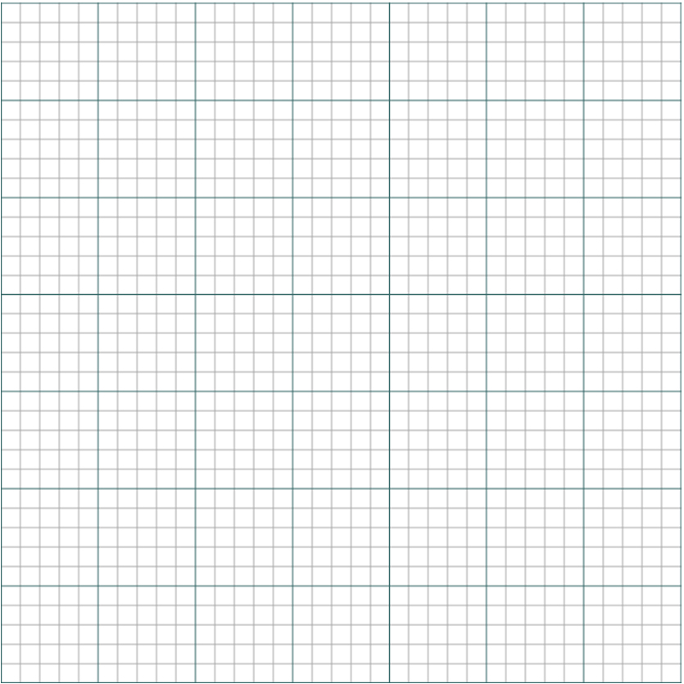

1. Now there teacher gets them to put on these special blue glasses and test another light. The blue glasses make the laser light look bright white, but this is not its true colour. The students determined that at an average angle of incidence of 35o produces an average angle of refraction of 20o.

Use your graph and data sheet to determine the colour of the laser light. Show all necessary calculations and logic.

NOTE air has a refractive index of 1.0027 and in a vacuum the refractive index is 1. (5 marks)

$\frac{sin θ_{i}}{sin θ_{r}}$ = $\frac{sin 35}{sin 22}$ = 1.68 (1 mark)

Reading off the graph this gives a wavelength in air of 295 nm (from line of best fit) (1 mark)

$\frac{λ_{vacuum}}{λ_{air}}$ = $\frac{n_{air}}{n_{vacuum}}$

$\frac{λ_{i}}{295}$ = $\frac{1.0027}{1}$ (1 mark)

λvacuum = 296 nm (1 mark)

From the data sheet this falls into the range of ultraviolet radiation (1 mark)

1. What is an appropriate aim for this experiment (2 marks)

**To study the refractive angles (incidence and refractive) (1 mark) of different coloured lights (1 mark) when passing through glass.**

______________________________________________________________________________________________________________________________________

1. Complete the following:
2. Independent Variable: (1 mark)

**The colour of the laser light (red, blue, green and yellow)**

**The angle of incidence and refraction (degrees)**

**Same glass prism that the light passed through**

**Same air medium**

**Same intensity of light sourced.**

________________________________________________________________

1. Dependent Variable: (1 mark) ________________________________________________________________
2. Controlled Variables: (1 mark) ________________________________________________________________________________________________________________________________